PATIENT REGISTRATION / INTAKE FORM
MRN #: ___________
Office Use Only

Patient’s Legal Name: __________________________________________
Last First M.I.
(Other\Maiden): ______________________________ Date of Birth: ___________________ SSN: ____________________

Mailing Address: ___________________________________________________________________________
Street/PO Box City State Zip
Home #: _______________________ Work #: ______________________ Cell #: _______________________
Email Address: _____________________________________________________________________________

Ethnicity (Check One): Hispanic or Latino Not Hispanic or Latino Decline to Report
Race (Check all that Apply): Alaska Native/American Indian African American Asian Pacific Islander Caucasian Decline to Report

If Alaska Native/American Indian:
Tribe: Blood Quantum: ____________________________
Please provide proof of Enrollment or Certificate of Indian Blood (CIB). If you do not have proof, please inquire about a Release of Information so we may obtain your enrollment on your behalf. If you have not applied for a CIB, please inquire about our Enrollment program and we can help you with that process.

Gender Identity (Check One): Male Female Transgender Male/Female-to-Male
Transgender Female/Male-to-Female Other Choose not to Disclose
Sexual Orientation (Check One): Straight Lesbian or Gay Bisexual Something else
Don’t Know Choose not to disclose

Marital Status (Check One): Single Married Life Partner Divorced Widowed Separated
Preferred Language: ____________________________________

Emergency Contact: _________________________________________________________________________ Name Relationship
__________________________________________________________________________________________
Street/PO Box City State Zip Phone #

Occupation: Employer: ______________________________________
U.S. Veteran: Yes No Service Branch: ________________________________________
MEDICAL INSURANCE
Who will pay for your Visit? Please provide proof of coverage.
Primary (Please Check one): IHS (Indian Health Services) Medicaid Medicare
Private Insurance VA (Veterans Affairs) Other
Insurance Carrier Name: _____________________________________________________________________
Carrier’s Phone #: __________________________________________________________________________
Employer: ________________________________________________________________________________
Policy #: __________________________________ Group #: _______________________________________
Subscriber Name: Subscriber DOB: ________________________________ Relationship to Patient: _____________________________________

Secondary (Please Check one): IHS (Indian Health Services) Medicaid Medicare
Private Insurance VA (Veterans Affairs) Other
Insurance Carrier Name: _____________________________________________________________________
Carrier’s Phone #: __________________________________________________________________________
Employer: ________________________________________________________________________________
Policy #: __________________________________ Group #: _______________________________________
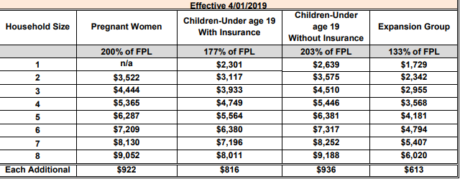
Subscriber Name: Subscriber DOB: ________________________________ Relationship to Patient: _____________________________________
Do you take home a household income within this Federal Poverty Guideline Levels for Alaska? Please circle the household size and monthly income. This will help determine eligibility for insurance and other programs and opportunities.

Certification Statement

I certify that the information above is true and accurate to the best of my knowledge.

Patient Name (print): __________________________________________
Patient Signature: _____________________________________________ Date:

